Technological Progress

Technological innovation and progress are always somehow underrated by both individuals and enterprises, even by those who are on the tech business. Humankind has a history for naivety when it comes to thinking about the future.

We tend to be biased by the magnificence of our own discoveries, we tend to think that we know it all, that we have done everything there is to do, in 1899 Charles H. Duell the Head of the US Patents Department said that everything that could be invented was already developed by that time. If we look back 100 years, we will barely recognize our own earth, the people and the ways things were done, how we faced nature and how we survived and thrived.

Needless to say, a lot has happened in terms of innovation since Mr. Charles Duell said there was nothing more to be done.

Interestingly also the same concepts of progress and innovation have changed over the years, back then they must have meant how we improved life quality, how we made industry more efficient, how we improved communications and ways of interacting, also sadly how we improved massive destruction means. Not until recently these two concepts have practically migrated 100% to the technological area, every major step relates to some degree with how computers, robots and artificial intelligence, machine learning and automation make life easier and also expand the possibilities to previously unknown areas.

Might be safe to say that progress and innovation themselves relate almost completely with how computing has progressed. This however is not unknown to anybody and certainly not surprising. Computers have crossed many borders and now they are scratching the surface of jumping into the world of intelligence and who knows maybe even consciousness.

It is such the change of mind that living in these times has caused that we even hear Elon Musk, recognized tech man, world billionaire and genius, say that the probabilities of us not living in a computer driven simulation are as little as almost non existing.

Taking this into consideration it is of our interest to analyze what has changed along the way.

So, first of all computers consume resources, mainly electrical energy to function properly; well it seems that even though computers have become more and more complex and the tasks they accomplish have also evolved, the amount of electricity needed to feed them has dropped significantly, in the next graph we can see how many Watts are needed to process 1 MIPs (Million instructions per second) over history:

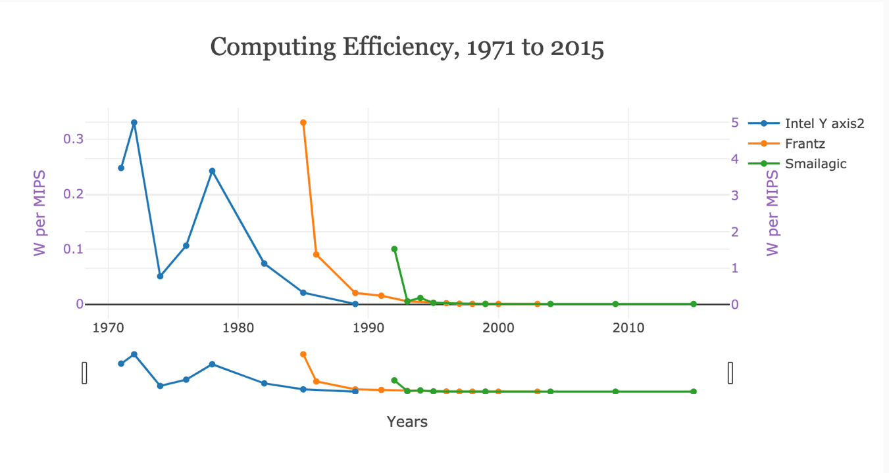

In this next graph we see the evolution of Microprocessor speed as measured in Hertz (pulses per second) generated by the computer’s oscillator. This is a measure of a computers overall speed and performance; it is really impressive to see a nearly exponential growth over time.

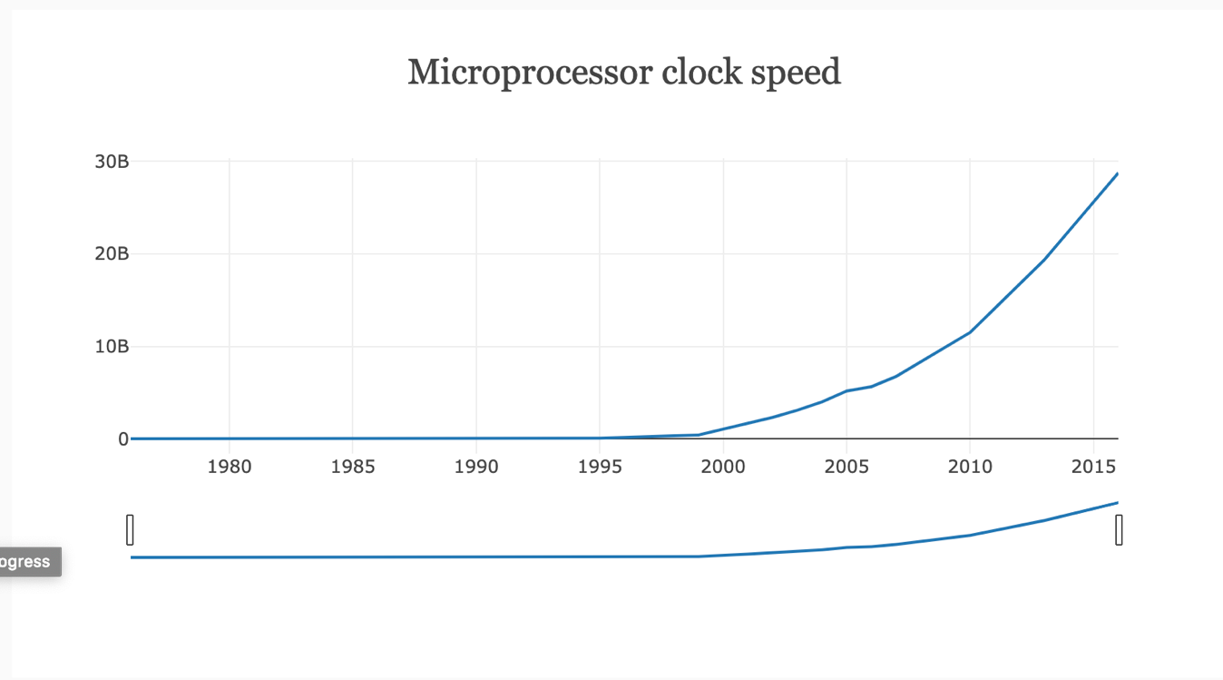

Another way to measure computing performance is by considering how many FLOPS (floating-point operations per second) the computer is able to handle. This units stand for more complex operation rather than just “instructions per second”, floating points are used for processing very large or really small numbers.

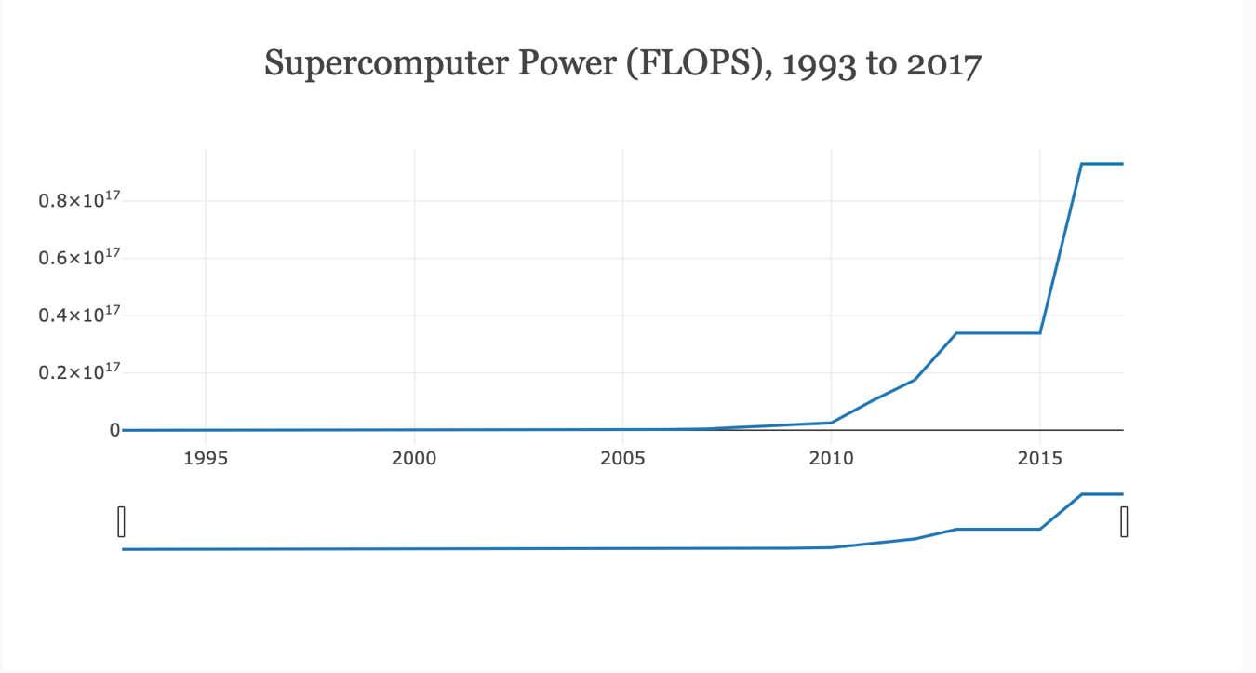

In another department, it is also amazing to see how much technology has evolved in terms of mobility and transportation, it is well know that this industry plays a major role in the modern world which is all about having everything connected with everything else, until we have teleportation at least! Before 1900 we didn’t even have the ability to make machines fly, however since then the autonomy of this machines has sky rocketed: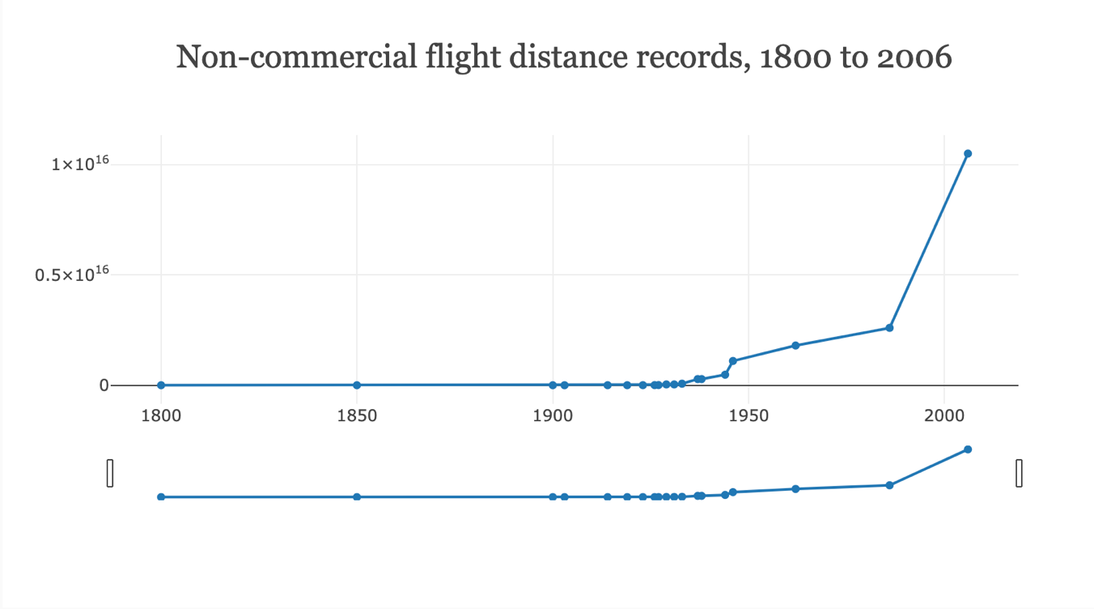

It is also well known that a very popular section of technological breakthrough is how well we manage to imitate God and try to generate life inside a lab tube; this industry began by analyzing the microscopic components of organic structures and has gone as far as being able to replicate complete genome schemas at a DNA level for most organic compositions, including the human being. However this kind of research has turned out to be quite costly due to the inherent complexity of the task, surprisingly however what we are measuring here is the non-linear way of the relationship existing between sequencing DNA pairs and its cost, which in most cases is the real road blocker for most technological breakthroughs, keeping the price steady at 1 US we are able to sequence a surprisingly increasing amount of DNA: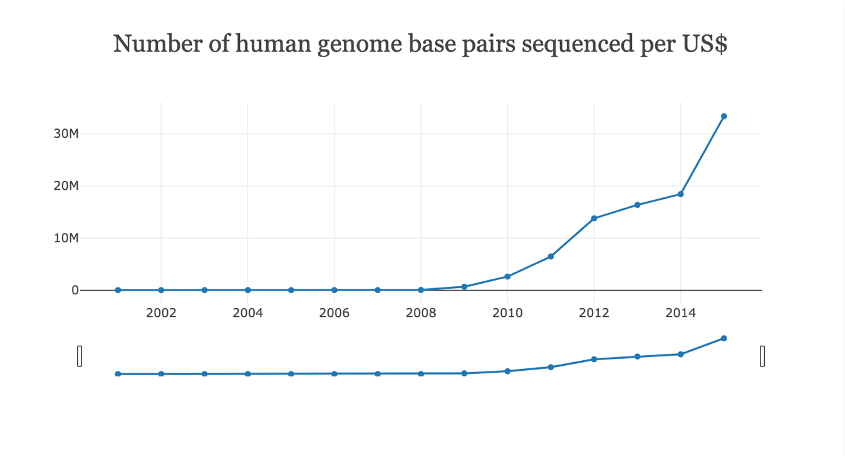

Finally and in the same train of though regarding the economy and technology, when comparing pricing levels for several products across several industries we can see that most technological related products are cheaper as time progresses, which doesn’t happen for other industries like education, healthcare and housing services. 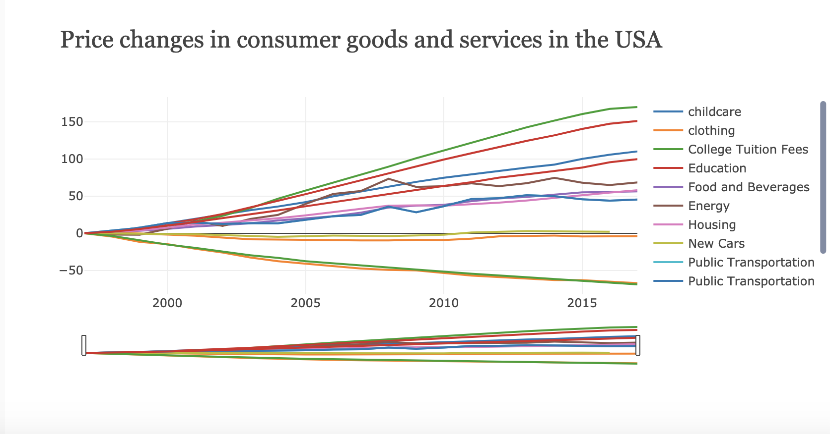

What is interesting to analyze here is the non-linear way of growth for this tech related areas, exponential growth is a really interesting subject, if you fold a piece of paper 103 time it would be as thick as the know universe (93 billion light years), I will give you a minute to chew on this.

OK moving on.

This may appear unthinkable, but it is true, this is achieved by exponential growth, this is why this is so relevant. Elon Musk said that in the 70s we had pong, now 50 years after we have full near immersive virtual worlds to play in, "If you assume *any rate of improvement at all* then games will become indistinguishable from reality…"

So, we have come a long way from thinking that all that could possibly be invented was already invented to think of our own experience of reality in technological terms. And who knows what more could be out there.